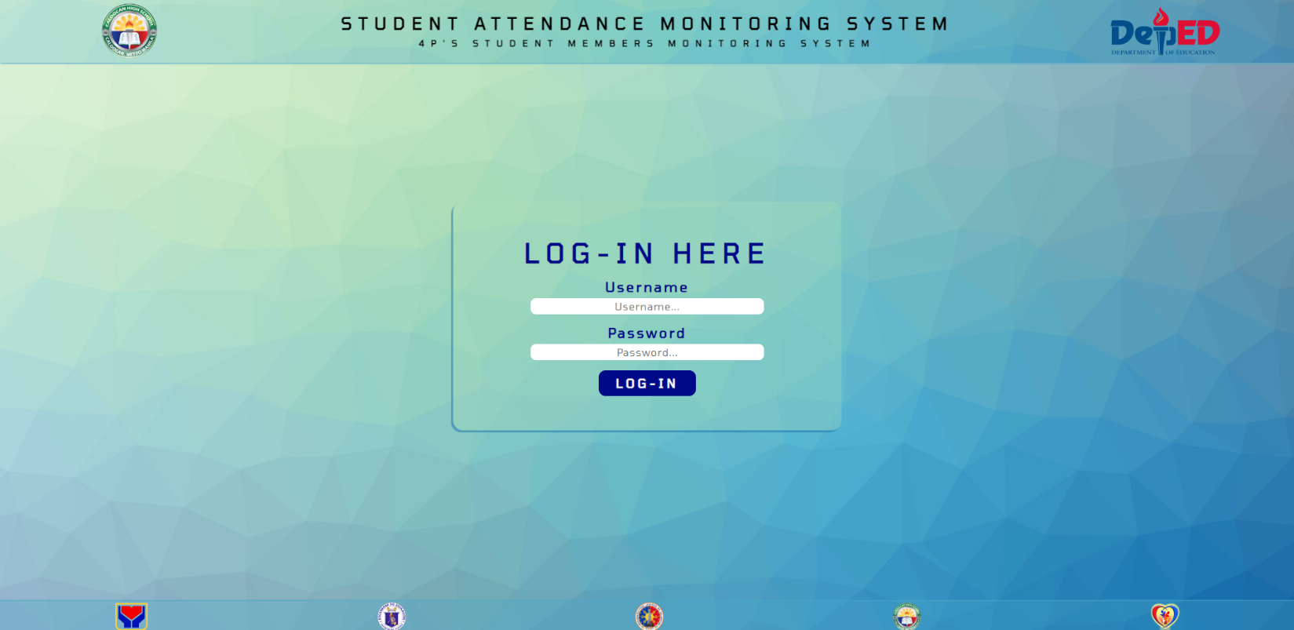

This is the login page of our system. Only the appointed admins can access the system that’s why we made a default account exclusively for them to avoid unnecessary security breach.

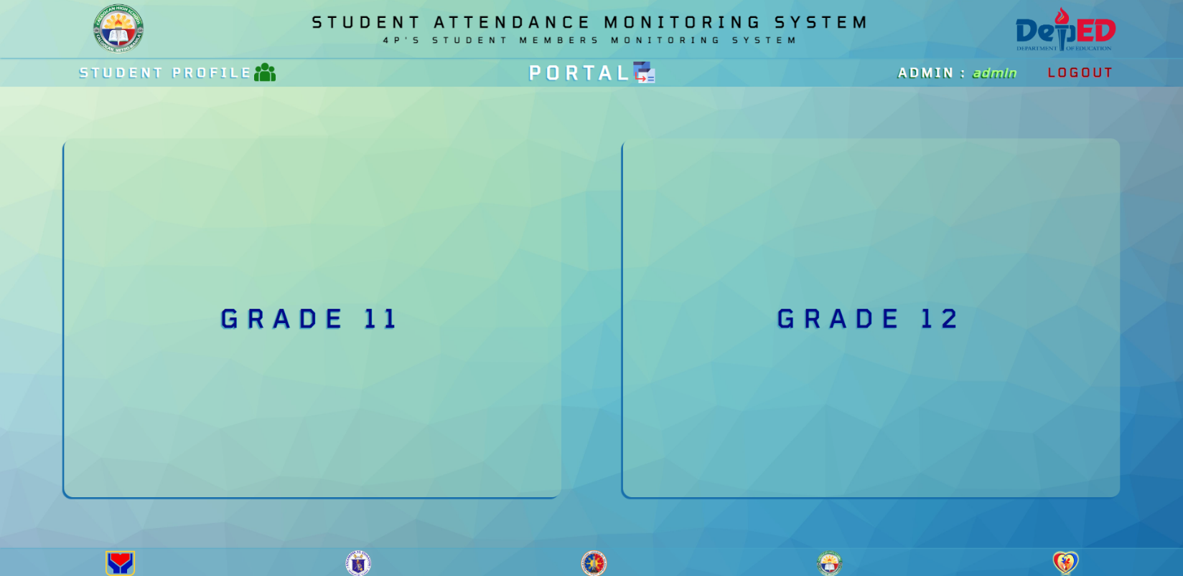

After logging in, the system will show 2 portals. The admin will choose what grade level he/she will update or view. Since the system is only made for Senior High School Students, the available grade levels are only Grade 11 and 12.

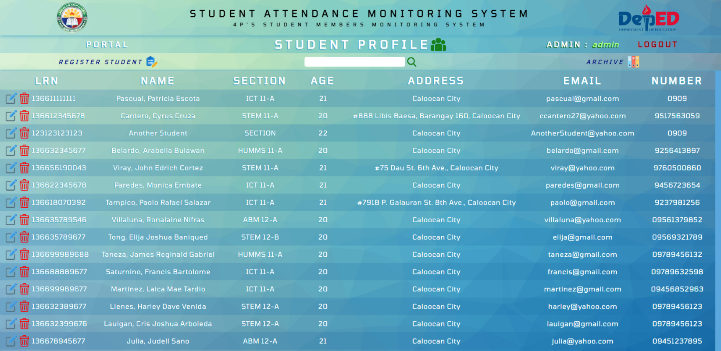

The student profile page is consist of all the student information who are registered in the system. This is like the database of the senior high school students of Caloocan High School.

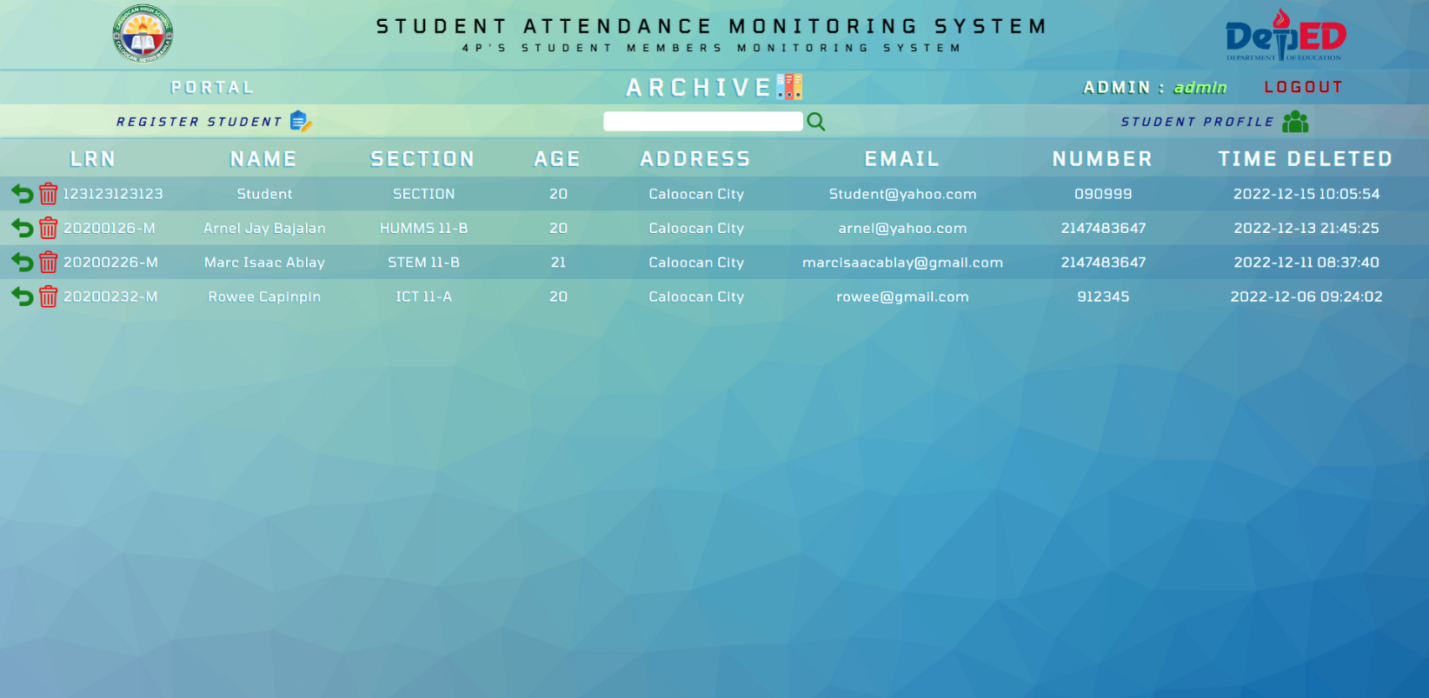

The archive page is where the deleted student in the student profile go to. The purpose of this page is to serve as a backup for deleted information, and when the admin needs it, he/she can restore that data easily.

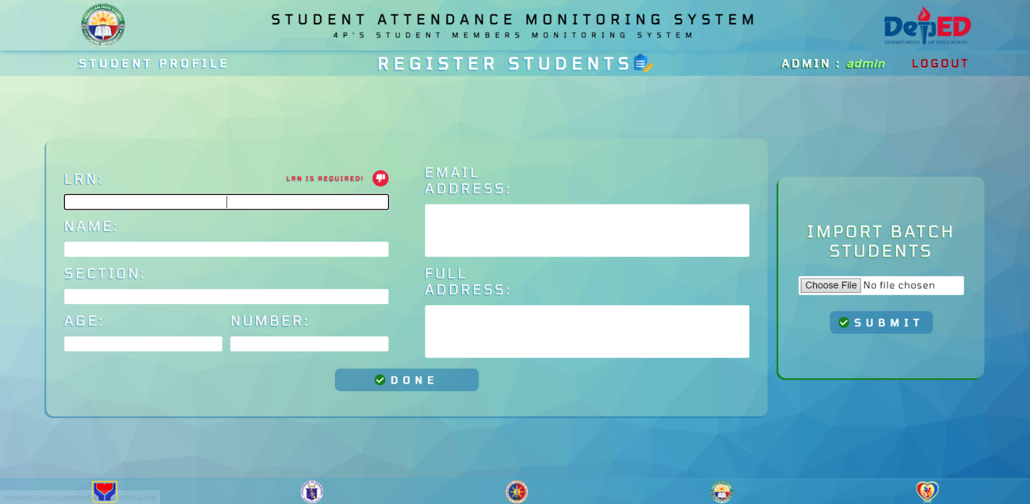

This is the registration page; this is where the admin will input the necessary information of the student before storing it in the database. We also included an import feature so that the admin can upload an excel file to easily register multiple students.

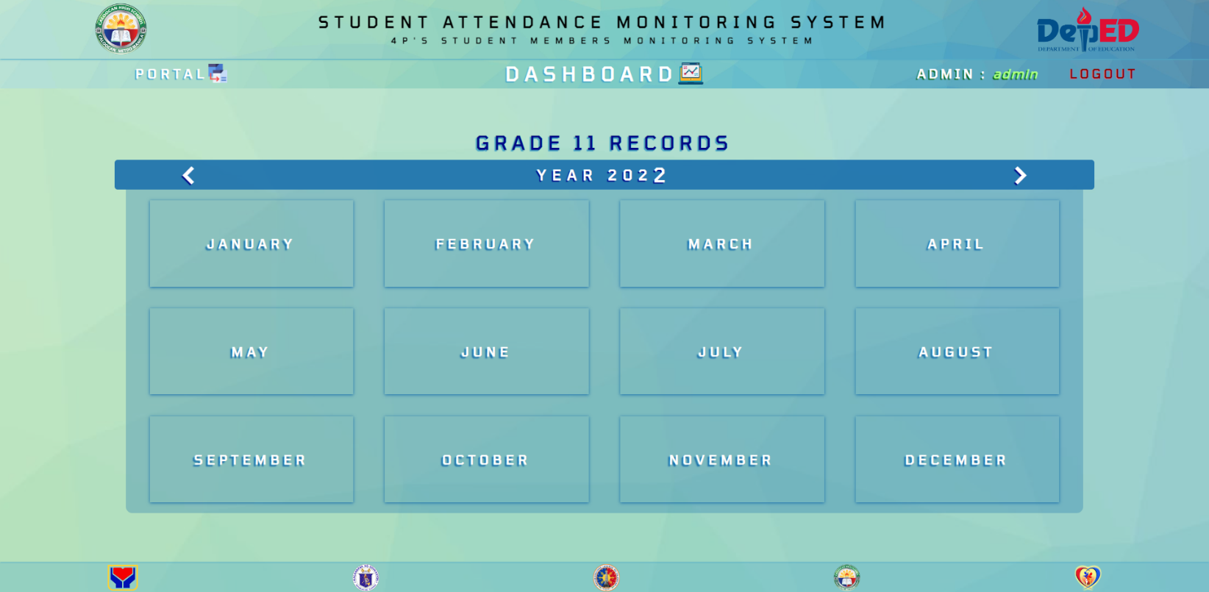

The dashboard page shows the summary of data that is inside a whole month in our system. It shows the year and the month of a certain timeline and the necessary information inside them.

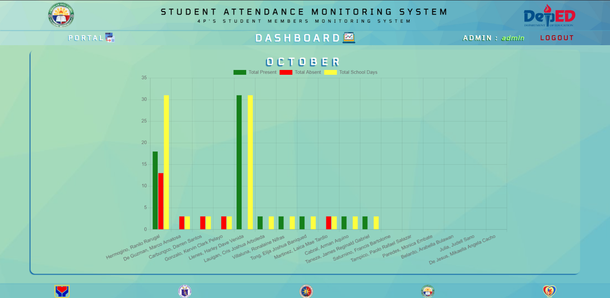

This is the example of the attendance summary in the dashboard. The admin can quickly review the attendance rate of a particular student in a whole month by looking at the bar graph.

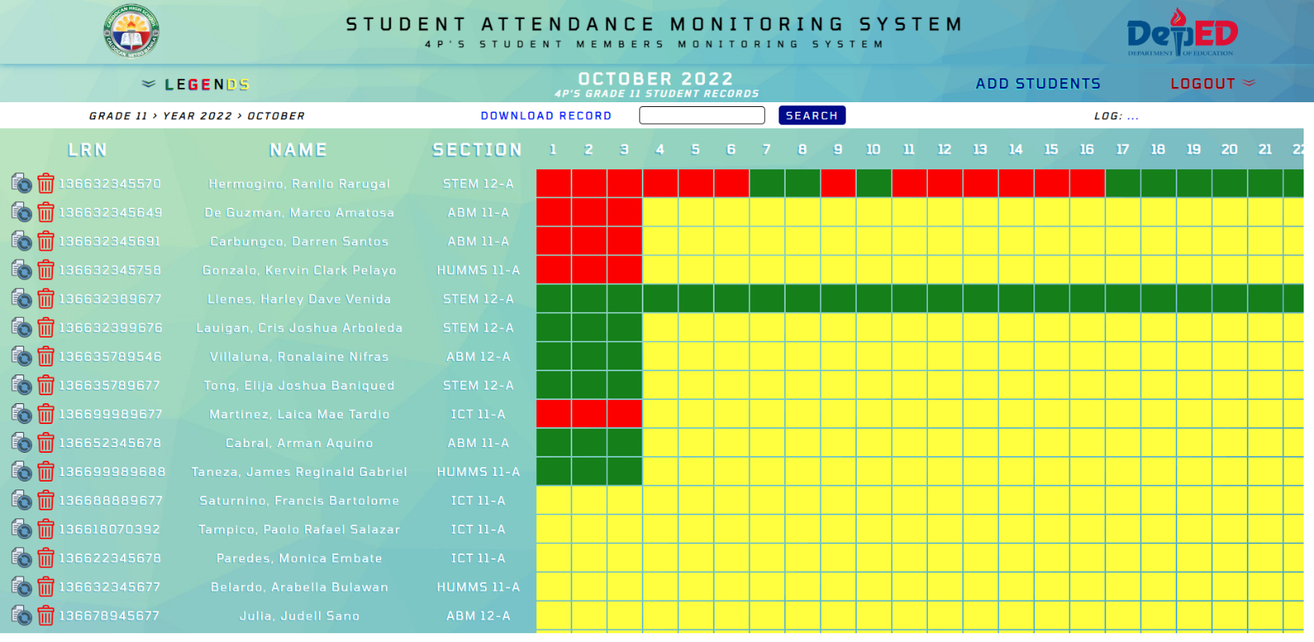

This is the main function of our system; it is the attendance monitoring process, by using colors, the admin can update whether the student is present (green), absent (red) or no class (yellow),

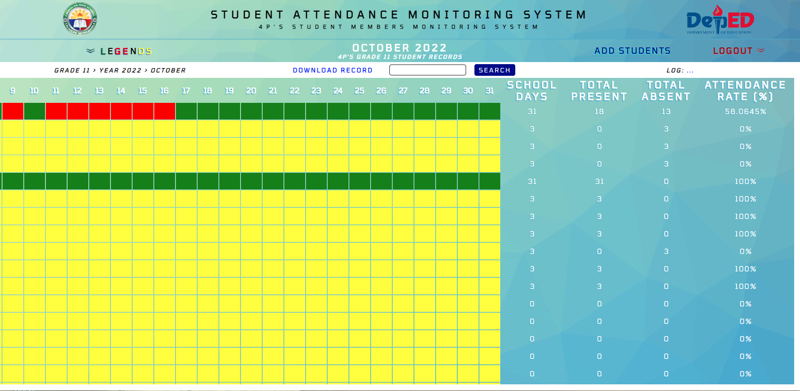

Aside from updating the attendance through colors, our system is also capable of computing the total attendance rate of a student in percentage, we can also see the total numbers of school days and total numbers of presents and absents the student has.

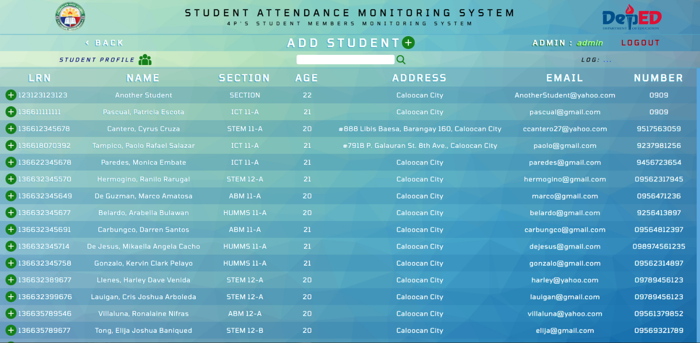

If the admin wants to add a certain student to a particular month of the year, he/she will just have to click the add students’ button, and the page will redirect to the student profile database, wherein the admin can choose/search who student/s he or she will add on the month.

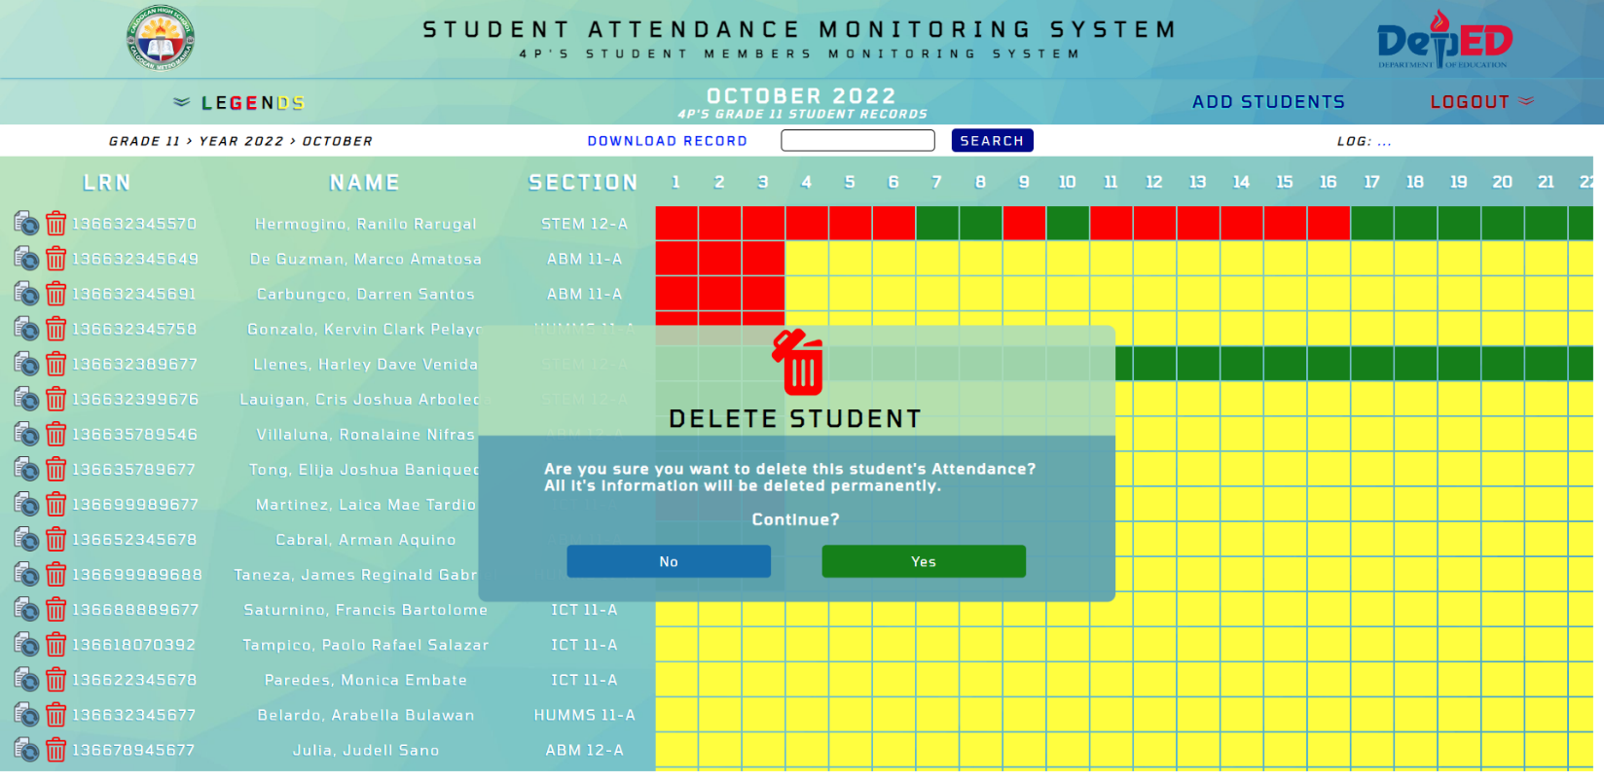

Our system also has a delete button, in case the admin added a wrong student on the list. An alert message will pop-up before the actual deletion of a student attendance.

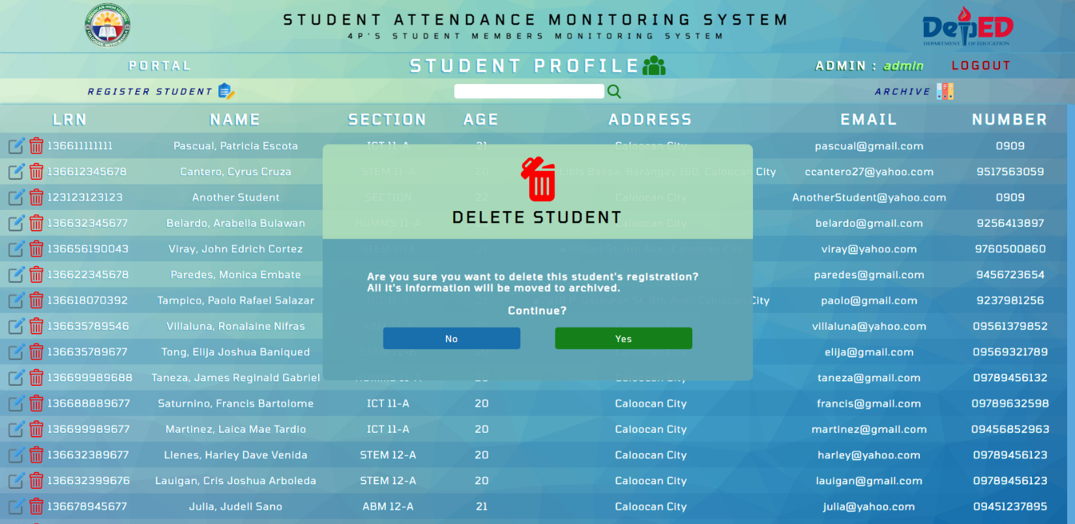

Our system also has a delete button, in case the admin wants to remove a dropped student from the database. The deleted student from the student profile will be placed in the archive.

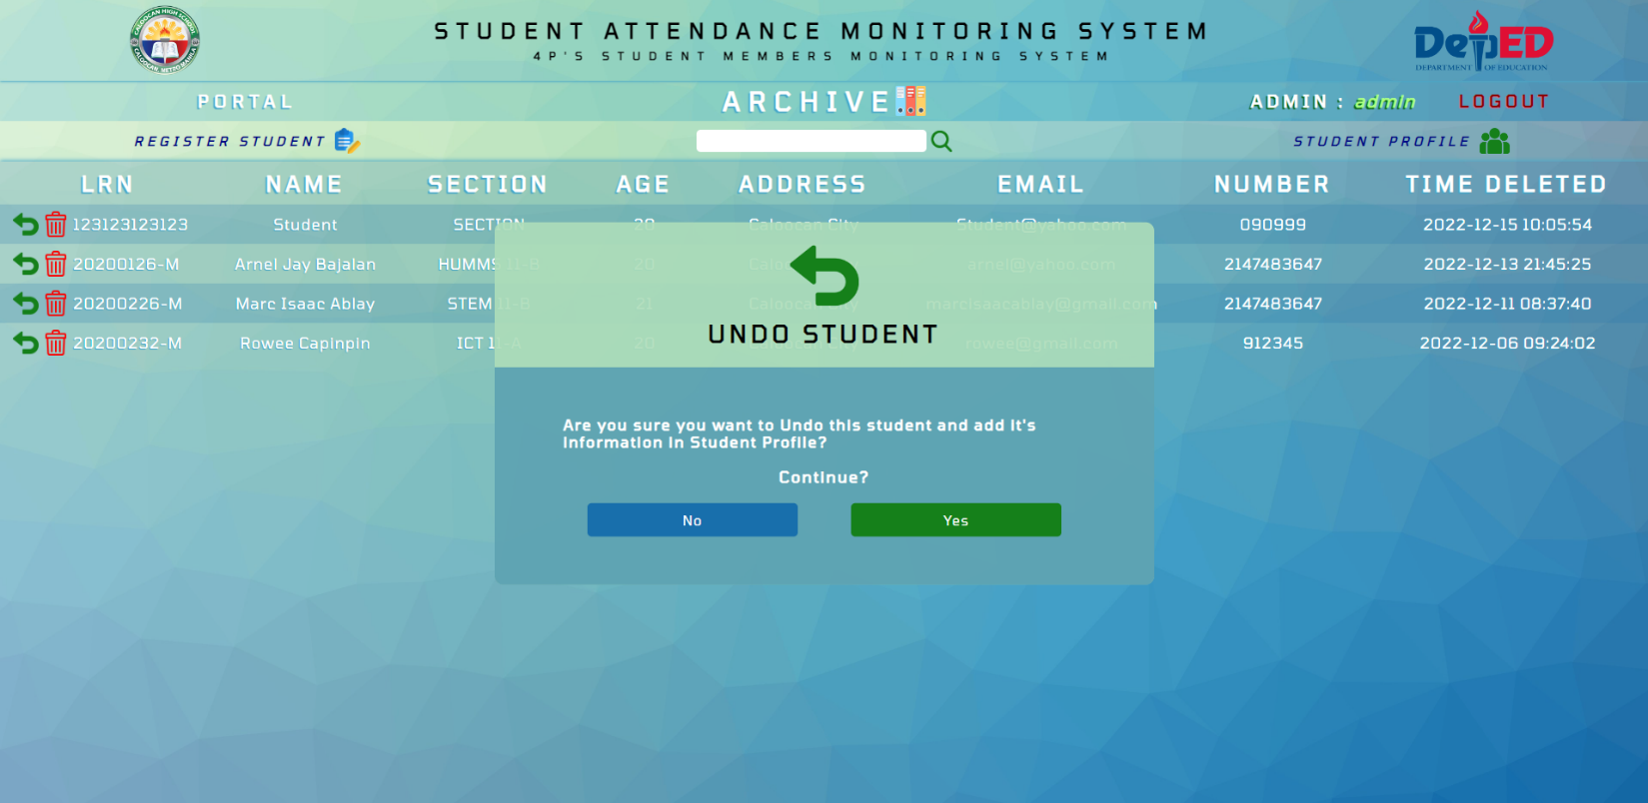

To restore the removed student’s data, the admin will simply go to the archive page and click the undo button. This will bring the student’s information back in the student profile database.

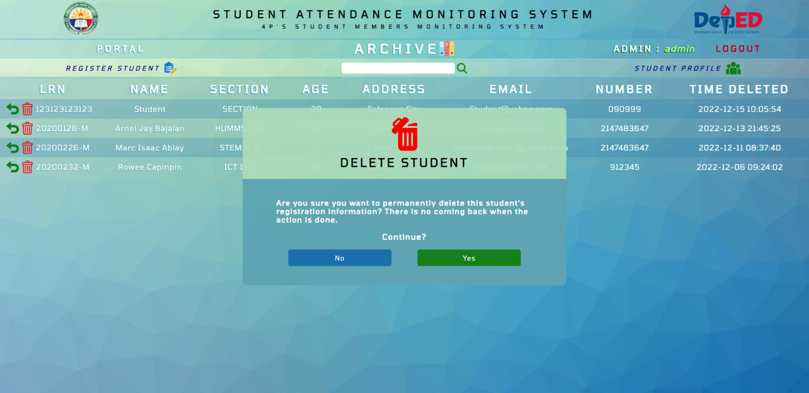

To permanently delete a student in our system, the admin must delete the record straight from the archive page.

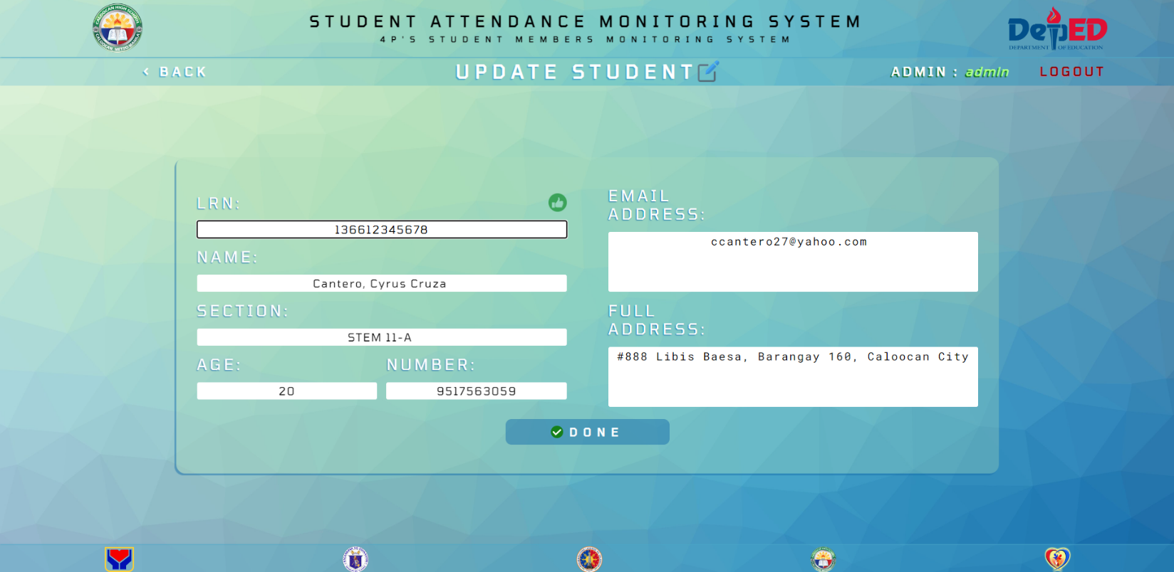

Lastly, the admin can update the information of a registered student by just clicking the edit/update button. To save any changes, the admin must click done.